|  |  |
| --- | --- |
| Course Name | ITD 2263 – Graphical User Interface Development |
| Instructor | Daniel D. Claborn |
| Student Name | Derrick McFall |
| Due date | Sep 24, 2017 11:59 PM |
| Grade | 100% |
| Grading Comments | Derrick,  You did a good job in completing the project.  Please keep up the good work.  Mr. Claborn |

Chapter 13

2. 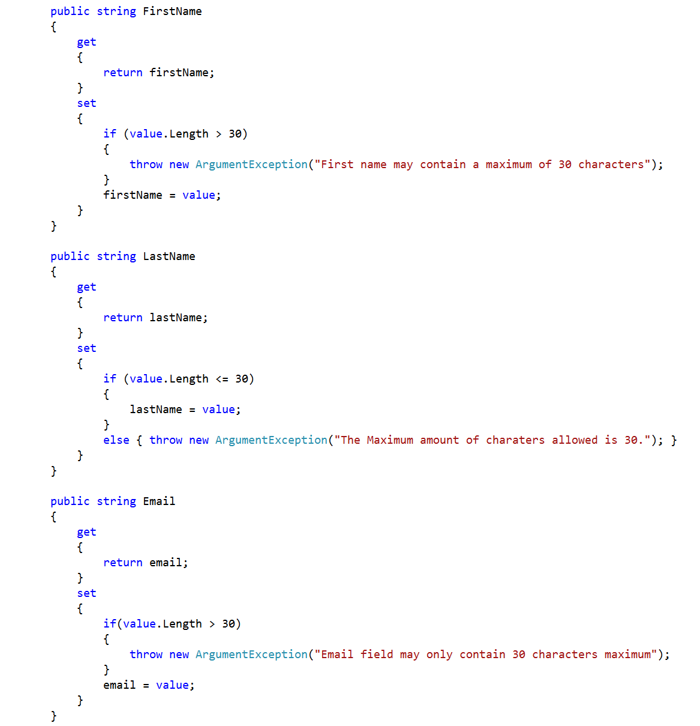4. 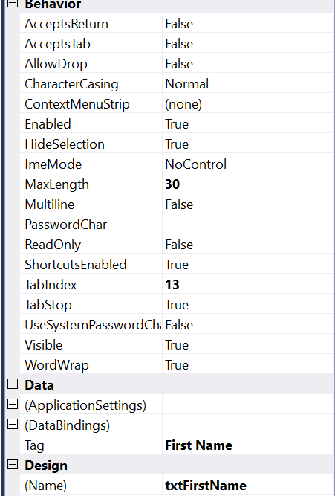

5. 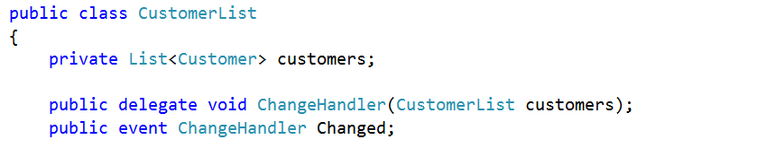6. 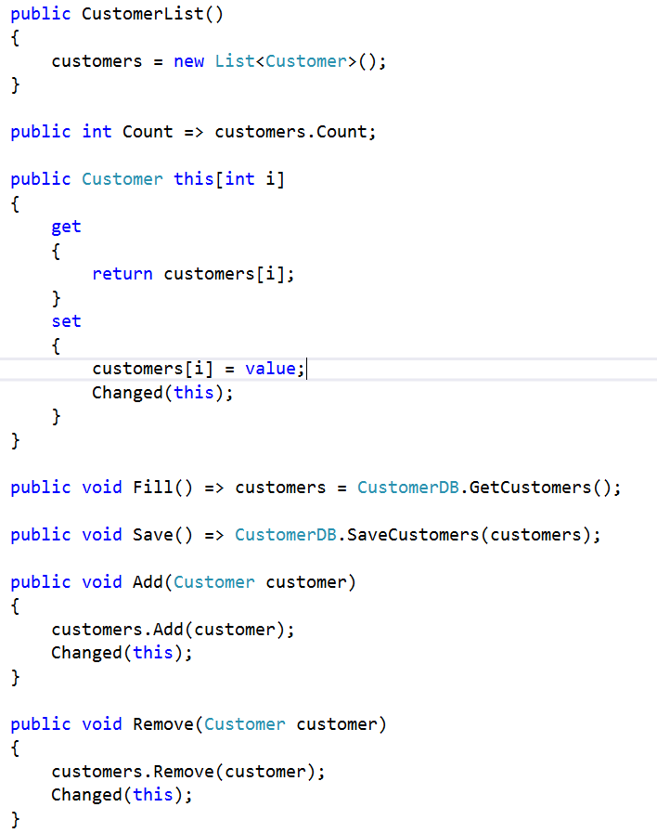

7. 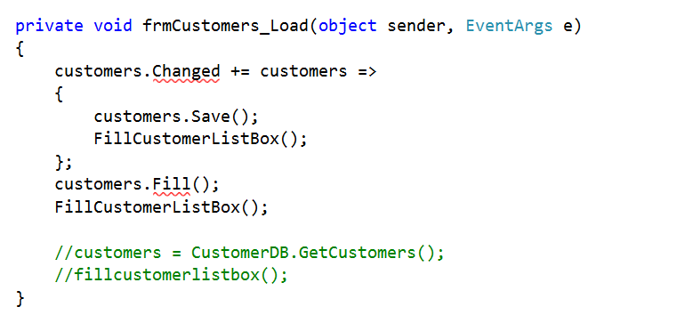

8. 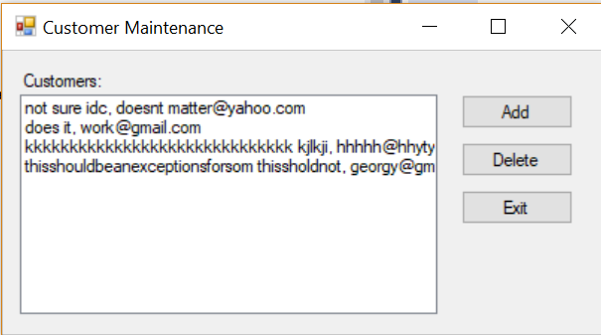

9. 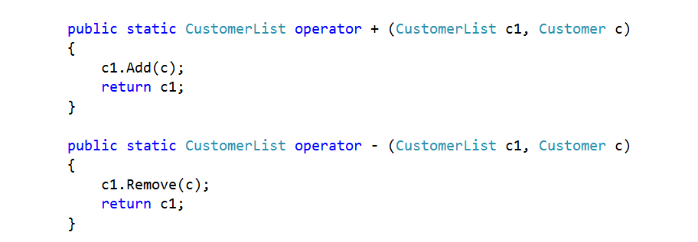

10. 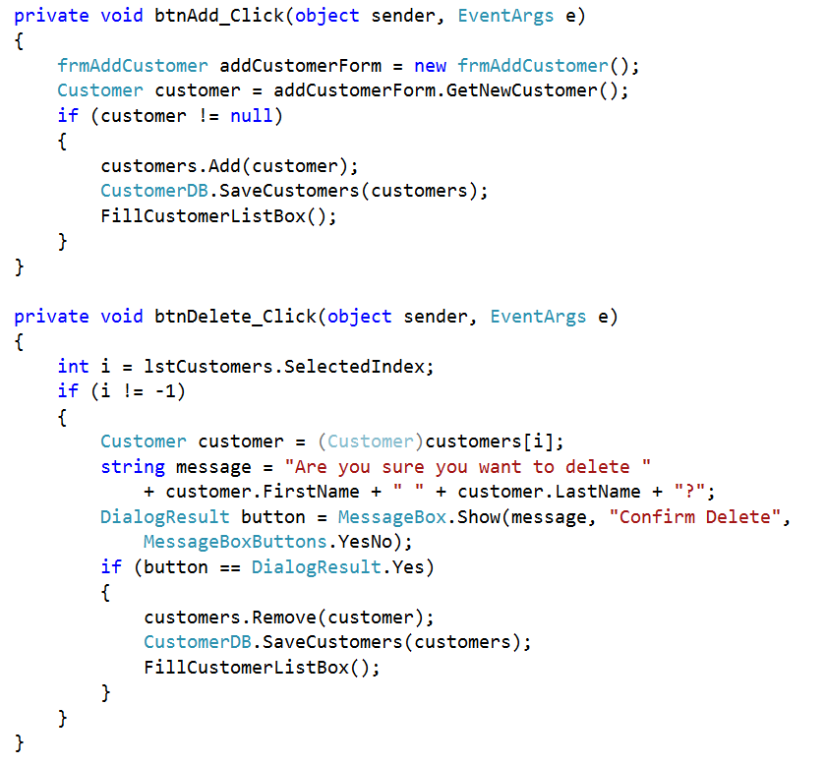

11-12. 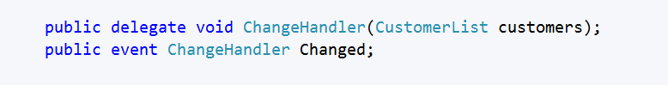

13. 